Mighty Eagles Rafting

Site Plan

David Jukes

WDD100-section

**Overview**

**Site Purpose**

The purpose of this site is to enable Mighty Eagles Rafting to provide information on the company and the services provided. The website will embody the edgy aesthetic of the founders. The site will highlight the high adventure of whitewater rafting. The site will serve as an entryway for our customers to begin their trek into the wild world of white water rafting. Ideally, a client will be able to review services provided, get answers to common questions, have the ability to contact the company, and book their trip all on the site with minimal need to call or interact with staff.

**Target Audience**

The audience for this website is potential customers and returning customers of the services provided by Mighty Eagles Rafting. Our target client is someone seeking adventure. They want to experience the thrill of whitewater rafting but may not know how to get started. We also need to accommodate those with experience so we can direct them to our more challenging treks.

## Branding

### Website Logo

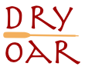

### Color Palette

https://coolors.co/d0db97-69b578-3a7d44-254d32-181d27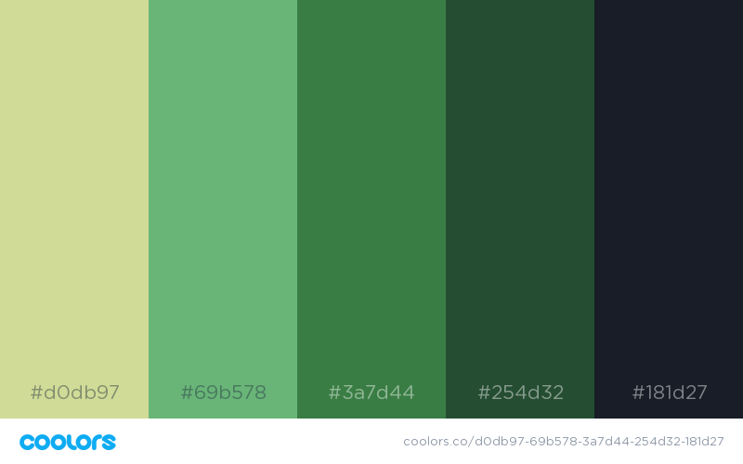

|  |  |  |  |
| --- | --- | --- | --- |
| **Primary** | **Secondary** | **Accent** | **Accent** |
| #d0db97 | #69b578 | #3a7d44 | #254d32 |

## Typography

### Heading Font: Exo 2 Semi Bold

Exo 2 is a modern True Type font family that is hip and cool. This matches the edgy theme of the company. For the Headings we will use the Semi Bold.

# We Run Rivers to Relax

### Paragraph (Body copy) Font: Exo 2

Exo 2 is a modern True Type font that is hip and cool. This matches the edgy theme of the company.

|  |
| --- |
| The best Whitewater Rafting in Colorado, White Water Rafting Company offers rafting on the Colorado and Roaring Fork Rivers in Glenwood Springs. Since 1974, we have been family owned and operated, rafting the Shoshone section of Glenwood Canyon and beyond. |
| Trips vary from mild and great for families, to trips exclusively for physically fit and experienced rafters. No matter what type of river adventures you are seeking, White Water Rafting Company can make it happen for you. |

## Navigation

### Main Navigation

### The main navigation for the site will be to the three basic pages:

### Home

### Rivers

### FAQ

|  |  |  |
| --- | --- | --- |
| Home | Rivers | FAQ |

Link:normal : #254d32

Link:hover : increase font size

Link:active:

## HTML Elements

### Links

Link:normal : #254d32

Link:visited: #254d32

Link:hover : #69b578

Link:active:

## Layout

### Site Map

Home

FAQ

Rivers

### Wireframes

### Main Page

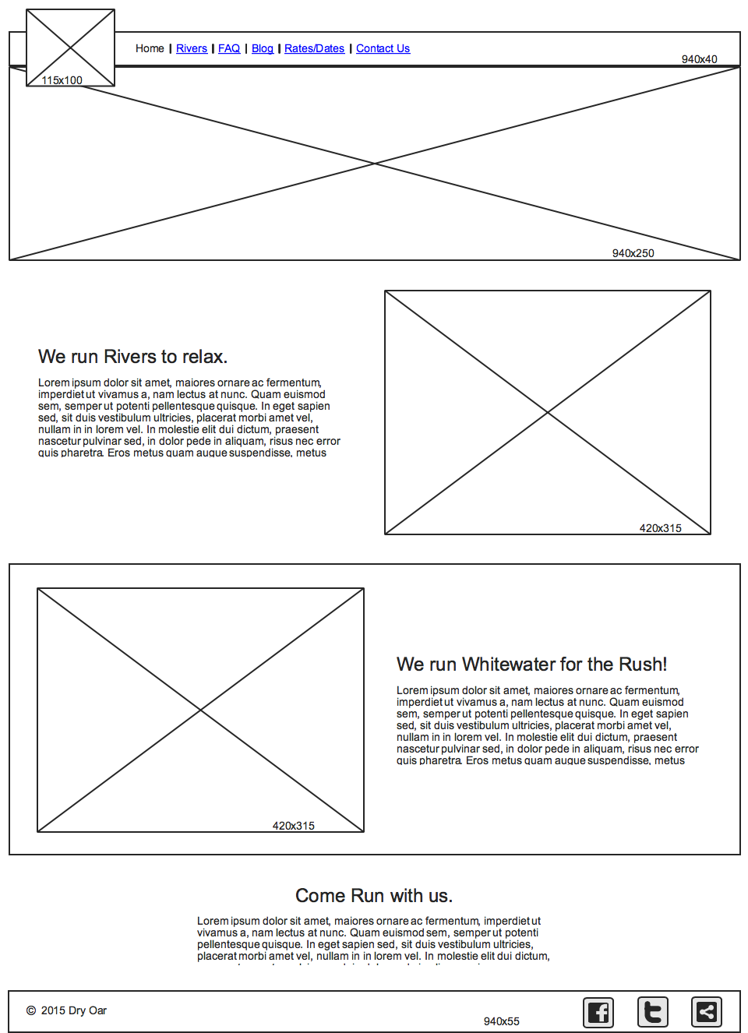

Rivers page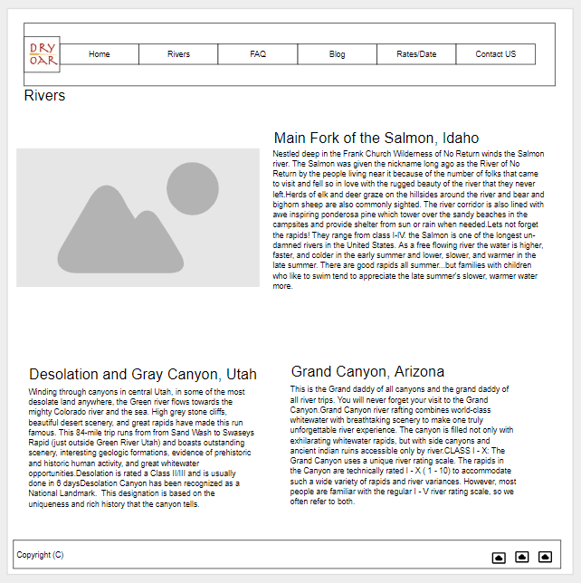

FAQ Page

